# Module 1 – Compute

Assignment 1: How to take a backup of your instance and launch new instance from the Backup.

Below are the steps, taken for taking backup and to launch a new instance using the AMI which was created for backup-

An Amazon Machine Image (AMI) is a supported and maintained image provided by AWS that provides the information required to launch an instance. You must specify an AMI when you launch an instance. You can launch multiple instances from a single AMI when you require multiple instances with the same configuration.

You can create AMIs when you want to establish a baseline, which is a reusable configuration for launching more instances. When you create an AMI of an existing EC2 instance, a snapshot is taken for all the volumes that are attached to the instance. The snapshot includes the device mappings.

Step 1: Create AMI from existing EC2 instance:

1. To create an AMI, select the desired instance, click on ‘Actions’, click on ‘Image and templates’ and select option ‘Create image’

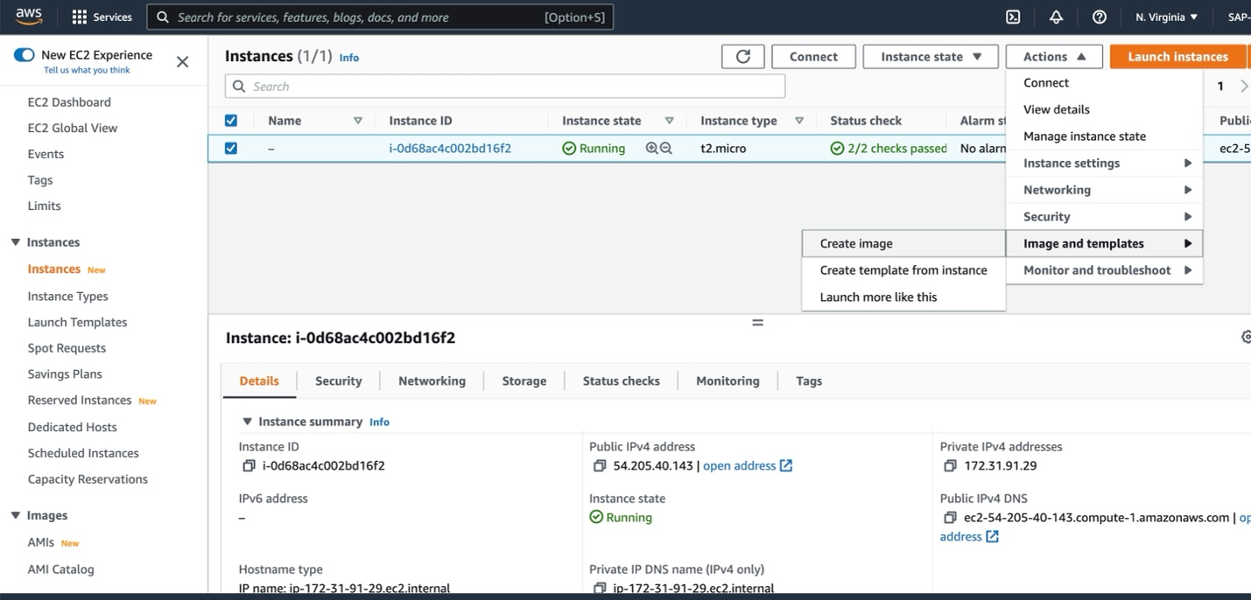

1. Configure below details for AMI:
   1. Image name – write the name of AMI
   2. Image description – provide description for AMI
   3. No reboot - If we want to shut down and reboot our instance on AMI creation, we can uncheck the ‘No reboot’ or if we don’t want it to shut down, select ‘No Reboot’.
   4. Instance Volume - All the attached volumes will be selected by-default, we can edit as per requirement and add more if require.
   5. Tags – Provide tags to categories services functionality wise or based on department or environment(Production, Development, Testing).
   6. Create Image – click on create image.

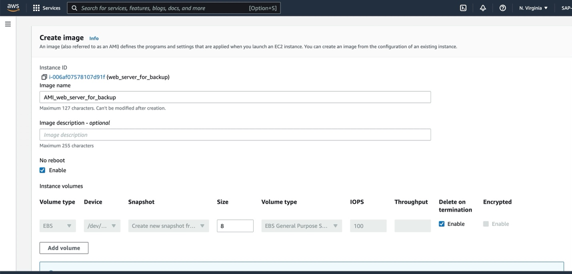

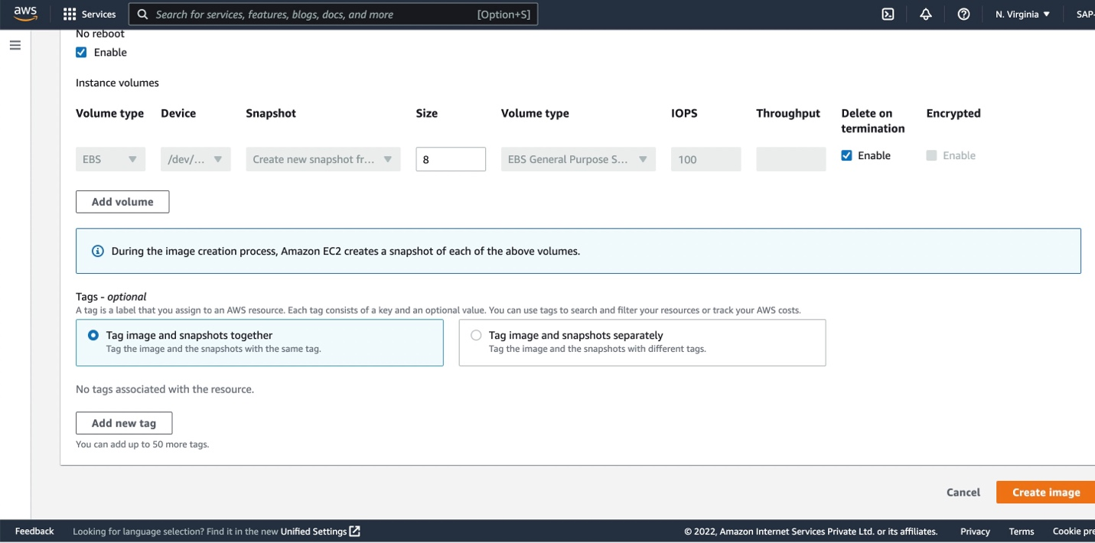

Step 2: Launch a new instance from an AMI

1. Click on AMI from left pane, Select the AMI to launch the instance, CLICK on ‘Launch Instance from AMI’. We will be redirected to a new instance launch page.

1. Configure below details to launch Instance from AMI:
   1. Name - Give name to instance
   2. Applications and OS Images – check Image catalog, it consists same configuration as our original instance.
   3. Instance Type – Check instance type, it will also reflect from primary instance.
   4. Key – Pair – Use the key pair, which was created for Primary instance.
   5. Network Setting – VPC, subnets, security group will be same as Primary instance. Which we can edit if require.
   6. Click on Launch instance

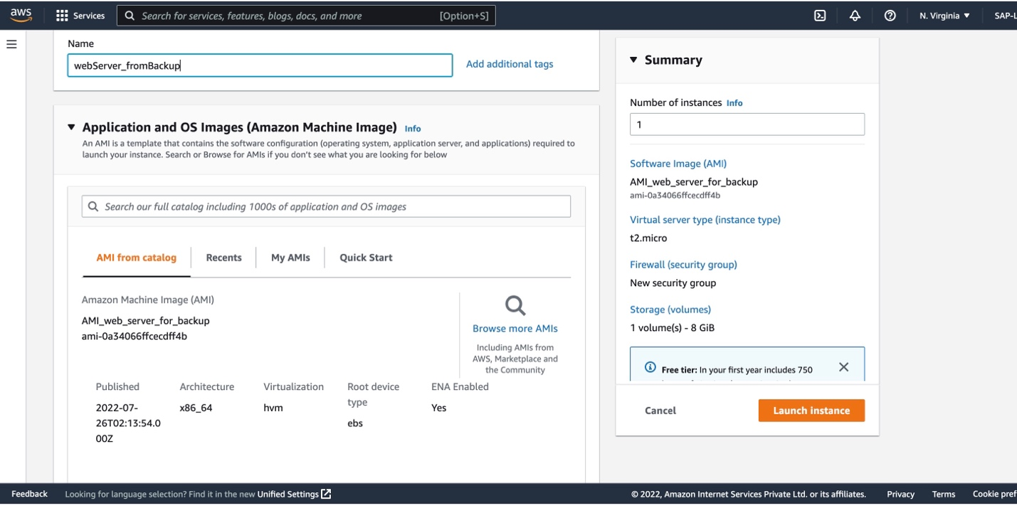

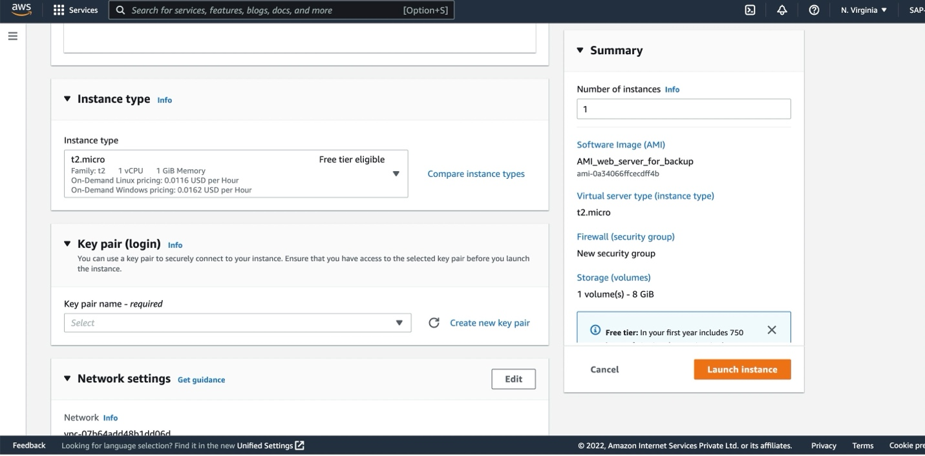

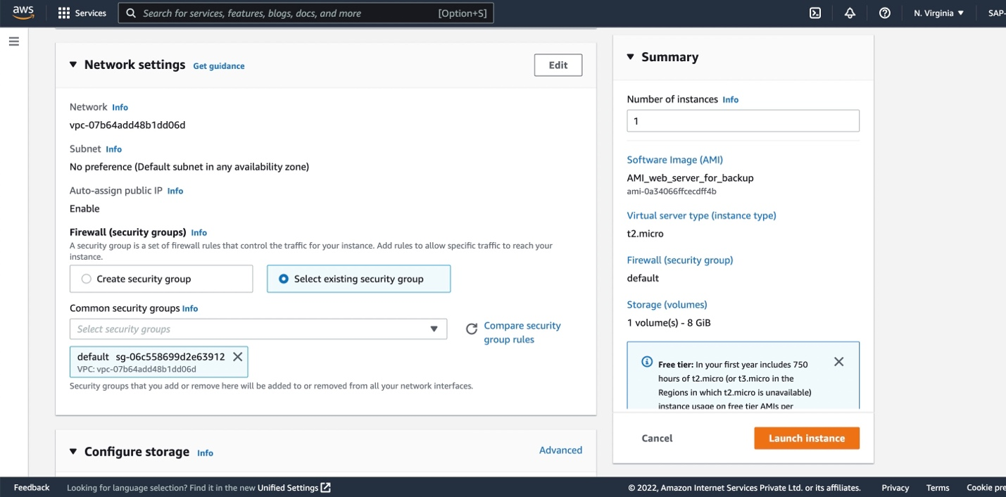

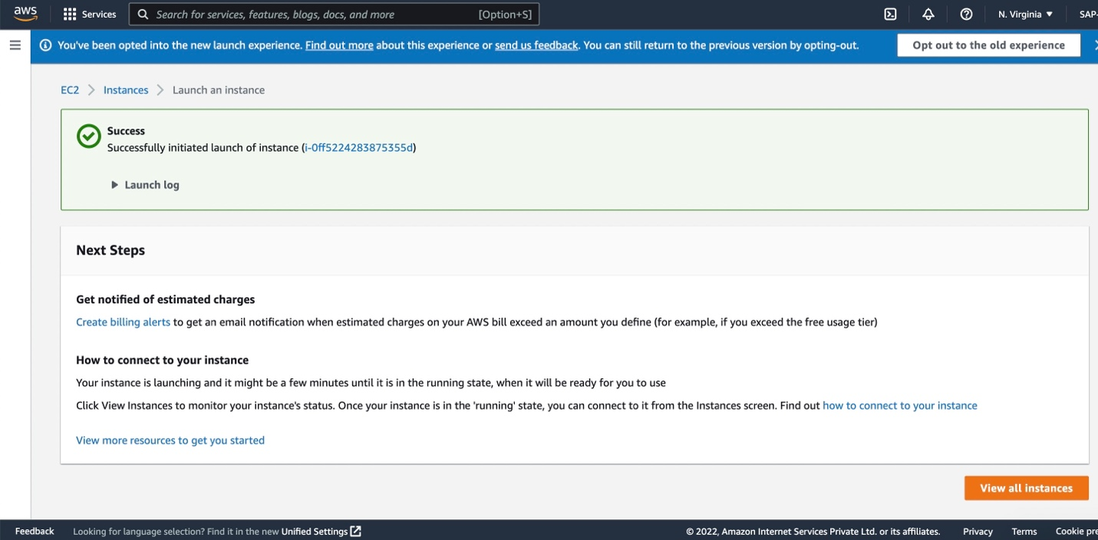

Go to instances and check for the new instance, which we created using AMI. In below image instance from backup is ‘WebServer_fromBackup’

